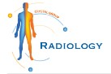Empowering Patients with Accurate CT-Scan Results from Crystal Radiology.

[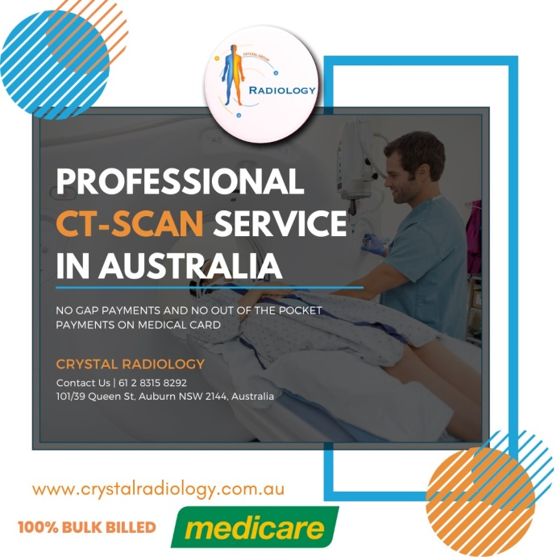](https://crystalradiology.com.au/ct-scan/)

**Introduction:**

Welcome to Crystal Radiology, your premier destination for state-of-the-art imaging services. In this blog, we shine a spotlight on our cutting-edge CT Scan services, highlighting their significance, benefits, and how they contribute to informed healthcare decisions. At Crystal Radiology, we are committed to [excellence](https://crystalradiology.com.au/about-us/), accuracy, and patient-centric care, making us your trusted partner for all your imaging needs.

**Understanding CT Scan Services:**

Computed Tomography (CT) scans are powerful diagnostic tools that produce detailed cross-sectional images of the body's internal structures. Using advanced X-ray technology and computer processing, CT scans provide comprehensive views of organs, tissues, bones, and blood vessels. This detailed imaging capability enables healthcare professionals to detect and diagnose a wide range of medical conditions with precision and accuracy.

**The Role of CT Scans in Medical Diagnosis:**

CT scans play a crucial role in [medical diagnosis](https://crystalradiology.com.au/appointment/) by providing detailed insights into various health conditions. Here are some key areas where CT scans are commonly used:

**Diagnostic Imaging:**

CT scans are instrumental in diagnosing conditions such as tumors, fractures, infections, and internal injuries. They provide clear and accurate images that help healthcare providers identify abnormalities and develop appropriate treatment plans.

**Cancer Detection and Monitoring:**

CT scans are valuable in detecting and monitoring cancers in different parts of the body. They assist oncologists in evaluating tumor size, location, and response to treatment, enabling personalized cancer care.

**Cardiovascular Evaluation:**

CT cardiac imaging allows for detailed [assessment](https://crystalradiology.com.au/harris-park-radiology/) of heart structure, blood vessels, and cardiac function. It aids cardiologists in diagnosing heart conditions, evaluating coronary artery disease, and planning interventions such as angioplasty or stent placement.

**Neurological Assessment:**

CT scans of the brain and spine help neurologists diagnose conditions such as strokes, brain tumors, hemorrhages, and spinal injuries. They provide vital information for treatment decisions and patient management.

**Benefits of Choosing Crystal Radiology for CT Scan Services:**

**Advanced Technology:**

Crystal Radiology utilizes state-of-the-art CT scanning equipment with advanced imaging capabilities. Our technology ensures [high-resolution](https://crystalradiology.com.au/granville/) images for accurate diagnoses and detailed evaluations.

**Experienced Radiologists:**

Our team of board-certified radiologists has extensive experience in interpreting CT scans. They collaborate closely with referring physicians to provide comprehensive reports and insights for patient care.

**Comprehensive Imaging:**

We offer a wide range of CT scan services, including routine scans, contrast-enhanced imaging, cardiac CT, and specialized studies. Our [comprehensive](https://crystalradiology.com.au/auburn/) approach caters to diverse medical needs and ensures thorough evaluations.

**Patient Comfort and Safety:**

At Crystal Radiology, we prioritize patient comfort and safety during CT scans. Our technologists ensure proper positioning, minimize scan times, and adhere to strict safety protocols to optimize the patient experience.

**Timely Reporting:**

We understand the importance of timely results in healthcare decision-making. Our radiologists provide prompt and detailed reports, enabling referring physicians to initiate appropriate treatments promptly.

**Why Choose Crystal Radiology for Your CT Scan Needs?**

**Accurate Diagnoses:**

Our advanced [CT scanning](https://crystalradiology.com.au/ct-scan/) technology and experienced team ensure accurate and reliable diagnoses, empowering healthcare providers with essential information for patient care.

**Convenience and Accessibility:**

With multiple locations across [insert locations], Crystal Radiology offers convenient access to CT scan services for patients and healthcare providers in the surrounding areas.

**Collaborative Care:**

We believe in collaborative care and work closely with referring physicians, specialists, and healthcare teams to deliver integrated and personalized healthcare solutions.

**Patient-Centered Approach:**

Your comfort, safety, and well-being are our top priorities. We strive to make your CT scan experience at Crystal Radiology as comfortable, efficient, and informative as possible.

**Conclusion:**

CT scans are invaluable tools in modern medicine, providing detailed and precise imaging for accurate diagnoses and treatment planning. At Crystal Radiology, we combine advanced technology, experienced professionals, and a [patient-centered](https://crystalradiology.com.au/butler-imaging/) approach to deliver exceptional CT scan services. Trust us to be your partner in healthcare, ensuring that you receive the highest standard of imaging excellence. Schedule your CT scan appointment with Crystal Radiology today and take a proactive step towards better health and wellness.



**Ready to schedule your ultrasound appointment?**

Contact us today at [**(02) 8315 8292**](https://crystalradiology.com.au/appointment/) or visit our website **(www.crystalradiology.com.au)** to learn more about our ultrasound services and book online. We look forward to serving you and ensuring your health journey is smooth and informed.

[**Our Service Locations:**](https://crystalradiology.com.au/contact-us/)

**Harris Park Radiology Granville Radiology**

|  |
| --- |
| Phone: (02) 7809 0804 |
| Email: info@granvilleradiology.com.au |
| Address:165 Clyde St, South Granville NSW 2142, Australia |
| Website: www.granvilleradiology.com.au |

|  |
| --- |
| Phone: (02) 8897 8686 |
| Email: info@harrisparkradiology.com.au |
| Address: 65 Harris St, Harris Park NSW 2150, Australia |
| Website: www.harrisparkradiology.com.au |

|  |
| --- |
| Phone: (08) 9544 3999 |
| Email: info@butlerimaging.com.au |
| Address: Shop 29/150, Camborne Pkwy, Butler, WA, 6036 |
| Website: www.butlerimaging.com.au |

**Auburn Radiology Butler Medical Imaging**

|  |
| --- |
| Phone: (02) 8315 8292 |
| Email: info@auburnradiology.com.au |
| Address:101/39 Queen St, Auburn NSW 2144, Australia |
| Website: www.auburnradiology.com.au |